Project Planning Phase

**(Product Backlog, Sprint Planning, Stories, Story points)**

|  |  |
| --- | --- |
| Date | 2 November 2022 |
| Team ID | PNT2022TMID49425 |
| Project Name | Smart Lender - Applicant Credibility  Prediction for Loan Approval |
| Maximum Marks | 8 Marks |

**Product Backlog, Sprint Schedule, and Estimation (4 Marks) ;**

|  |  |  |  |  |  |  |
| --- | --- | --- | --- | --- | --- | --- |
| **Sprint** | **Functional Requirement**  **(Epic)** | **User Story Number** | **User Story / Task** | **Story Points** | **Priority** | **Team Members** |
| Sprint-1 | Registration | USN-1 | As a user, I can register for the application  by entering my email, password, and confirming my password. | 2 | High | Pooja,  Mohanapriya,  Sivasathya ,  Yuvarani. |
| Sprint-1 |  | USN-2 | As a user, I will receive confirmation email once I have registered for the application | 2 | High | Pooja,  Mohanapriya,  Sivasathya ,  Yuvarani. |
| Sprint-2 |  | USN-3 | As a user, I can register for the application through internet | 1 | Low | Pooja,  Mohanapriya,  Sivasathya ,  Yuvarani. |

|  |  |  |  |  |  |  |
| --- | --- | --- | --- | --- | --- | --- |
| Sprint-1 |  | USN-4 | As a user, I can register for the application through Gmail | 1 | Medium | Pooja,  Mohanapriya,  Sivasathya ,  Yuvarani. |
| Sprint-1 | Login | USN-5 | As a user, I can log into the application by entering email & password | 2 | High | Pooja,  Mohanapriya,  Sivasathya ,  Yuvarani. |
| **Sprint** | **Functional Requirement**  **(Epic)** | **User Story Number** | **User Story / Task** | **Story Points** | **Priority** | **Team Members** |
|  | Dashboard |  |  |  |  | Pooja,  Mohanapriya,  Sivasathya ,  Yuvarani. |

**Project Tracker, Velocity & Burndown Chart: (4 Marks)**

|  |  |  |  |  |  |  |
| --- | --- | --- | --- | --- | --- | --- |
| **Sprint** | **Total Story Points** | **Duration** | **Sprint Start Date** | **Sprint End Date (Planned)** | **Story Points Completed (as on Planned End**  **Date)** | **Sprint Release Date (Actual)** |
| Sprint-1 | 20 | 10 Days | 24 Oct 2022 | 04 Nov 2022 | 20 | 04 Nov 2022 |
| Sprint-2 | 20 | 7 Days | 30 Oct 2022 | 06 Nov 2022 |  |  |
| Sprint-3 | 20 | 4 Days | 06 Nov 2022 | 10 Nov 2022 |  |  |
| Sprint-4 | 20 | 2 Days | 10 Nov 2022 | 12 Nov 2022 |  |  |

**Velocity:**

Imagine we have a 10-day sprint duration, and the velocity of the team is 20 (points per sprint). Let’s calculate the team’s average velocity (AV) per iteration unit (story points per day)

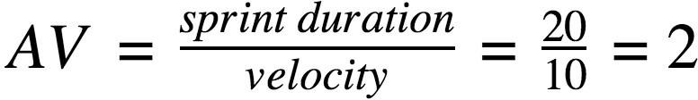

**Burndown Chart:**

A burn down chart is a graphical representation of work left to do versus time. It is often used in agile [software](https://www.visual-paradigm.com/scrum/what-is-agile-software-development/)

[development](https://www.visual-paradigm.com/scrum/what-is-agile-software-development/)  methodologies such as [Scrum.](https://www.visual-paradigm.com/scrum/scrum-in-3-minutes/) However, burn down charts can be applied to any project containing measurable progress over time.

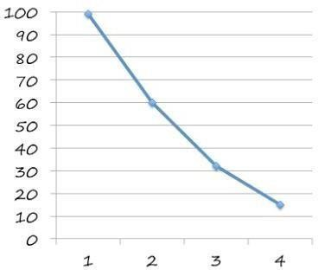

X - sprint and

Y - Pending hours.

In our project, there are 4 sprint activities. This chart is drawn by taking